GENTIC AI · QUICK SERVICE RESTAURANTS
Title
How We Turned 490K+ Transactions of Dark Data Into Real-Time Intelligence for a Leading Singapore QSR Chain
Subtitle
From manual labour reports to AI-powered conversational analytics — deployed in 4 weeks.

The Challenge
A leading QSR operator managing multiple outlets across Singapore was making critical workforce decisions in the dark.
Their labour analytics relied entirely on manual reporting and fragmented data sources — leaving managers unable to answer the questions that mattered most:
- Which time periods are most productive?
- Where is overstaffing or understaffing happening?
- How are labour costs impacting performance?
The answer wasn't more reports. It was real-time, AI-powered intelligence that anyone in the business could access — instantly, in plain English, without needing a data analyst.

What Algorims Built
We designed and deployed a Conversational Analytics Platform on AWS — a fully serverless, cloud-native intelligence system that transforms raw operational data into actionable insights through natural language.
The platform was engineered across six layers:
Data Ingestion & Storage Raw labour and transaction data ingested and structured in Amazon S3 — creating a single, reliable source of truth across all outlets.
Data Engineering Pipeline AWS Glue Crawler and ETL processes clean, transform, and optimise raw data for high-speed analytical querying at enterprise scale.
Analytics Layer Amazon Athena processes large datasets and computes critical business KPIs — including TCPMH (Transactions per Crew Man Hour), SPMH (Sales per Man Hour), and Labour Cost % — all validated against real business logic.
AI-Powered Natural Language Interface Amazon Q enables business users to ask workforce questions in plain English — and instantly receive AI-generated charts, insights, and contextual follow-up recommendations. No SQL. No analysts. No waiting.
Real-Time Dashboards AWS QuickSight delivers interactive, real-time visualisations — KPI monitoring across time periods, zones, and operational areas — giving every manager complete visibility at a glance.
Enterprise Security & Governance Full encryption, IAM role-based access controls, and comprehensive audit logging — built in from day one, not retrofitted after launch.

Technology Stack
Amazon S3 · AWS Glue · Amazon Athena · Amazon Q · AWS QuickSight · IAM · AWS KMS

Solution Architecture
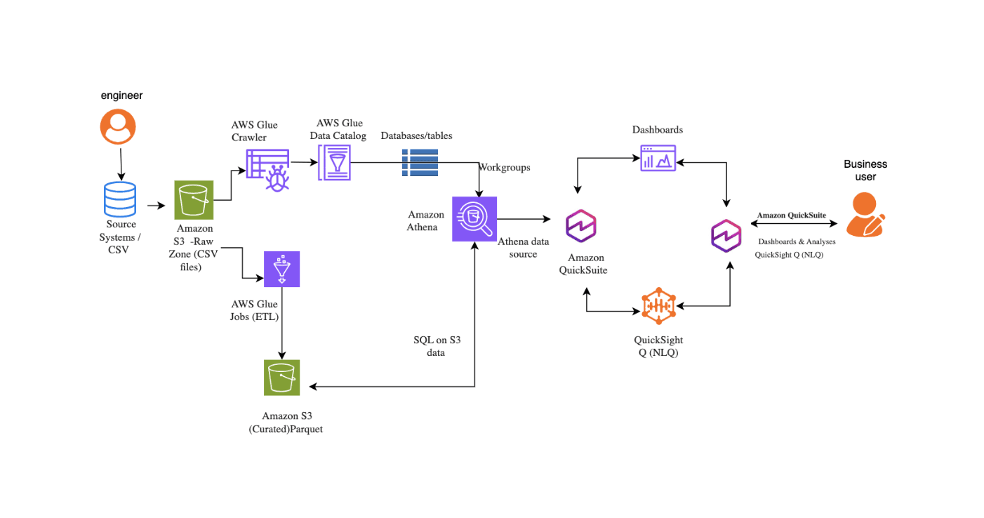
The Results
⚡ Instant Decision-Making Business users get real-time workforce insights through natural language — no analysts, no waiting, no bottlenecks. Decisions that once took days now happen in seconds.
📊 490K+ Transactions Processed 13 months of operational data processed with complete visibility — the foundation for every insight the platform delivers.
🔍 46% Productivity Gap Uncovered A previously invisible 46% productivity gap between operational time periods was discovered — enabling immediate, targeted workforce optimisation.
🚀 4 Weeks from Architecture to Production Fully designed, built, and deployed in just 4 weeks — delivering enterprise value faster than any traditional analytics programme.
👥 Proactive Workforce Optimisation Managers now make proactive staffing decisions driven by AI — reducing inefficiencies, controlling labour costs, and improving operational performance across every outlet.
🔓 Data Access Democratised Non-technical users across the business explore and interrogate operational data freely — no SQL skills, no technical dependencies, no delays.
☁️ Serverless AWS Architecture Built on a secure, fully serverless AWS stack — high performance today, infinitely scalable tomorrow.

Impact Summary
490K+ transactions. Zero manual reports. 46% productivity gap uncovered. Four weeks to production.

Got it — here's the fully rewritten case study:

Tag
AGENTIC AI · EDUCATION
Title
How We Eliminated Scheduling Chaos for a School — Replacing Manual Coordination with Intelligent Automation
Subtitle
From error-prone manual timetables to an AI-powered scheduling platform — delivering complete operational visibility and instant decision-making.

The Challenge
Managing a school's daily operations is more complex than it looks from the outside.
Every day, administrators juggle teacher absences, last-minute substitute assignments, room conflicts, and timetable changes — all manually, across disconnected spreadsheets and paper-based systems. The result was predictable: scheduling errors, operational bottlenecks, and administrators spending hours on coordination instead of leadership.
Three critical problems demanded an intelligent solution:
- Teacher absences created cascading disruptions with no fast, reliable way to assign the right substitute
- Manual timetable management was error-prone — double bookings, room clashes, and workload imbalances went undetected until they caused real disruption
- Decision-makers had no real-time visibility into operations — acting on instinct rather than data

What Algorims Built
We designed and deployed an AI-Powered School Scheduler System — a fully cloud-native, modular platform that automates the entire school scheduling lifecycle from timetable management to absence resolution, powered by natural language AI.
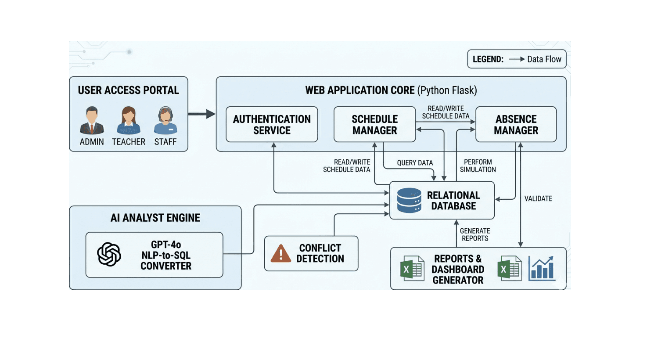
The platform was engineered across twelve integrated capabilities:
Core Web Application A secure, responsive web platform with role-based access for Administrators, Teachers, and Staff — seamlessly accessible across all devices.
Schedule Management Daily and weekly timetable views with real-time conflict detection — automatically identifying teacher clashes, room double-bookings, and workload imbalances before they cause disruption.
Absence Management End-to-end absence tracking with automated approval workflows and complete historical records — giving administrators full visibility and control.
AI Substitute Assignment Engine Intelligent automatic substitute allocation based on subject expertise, current availability, and workload balancing — ensuring the right teacher is assigned instantly, every time.
What-If Simulation Engine Scenario-based planning that lets administrators test the impact of teacher absences, departmental changes, and room unavailability — without touching live schedules. Plan confidently before committing.
AI Analyst Module Powered by GPT-4o — administrators ask operational questions in plain English and instantly receive AI-generated insights, SQL-driven analytics, and intelligent decision support. No technical skills required.
Real-Time Dashboard Live metrics and visual analytics covering teacher distribution, room utilisation, absence trends, and workload insights — giving every decision-maker a complete operational picture at a glance.
Conflict Detection Engine Automated alerts for scheduling conflicts — double-booking, room clashes, and workload violations — with intelligent resolution suggestions served immediately.
Reporting & Export Automated schedule reports, absence summaries, and substitute utilisation exports — ready when needed, without manual compilation.

Technology Stack
GPT-4o · Cloud-Native Architecture · Role-Based Access Control · Real-Time Conflict Detection · Serverless Infrastructure · Automated Reporting

Solution Architecture

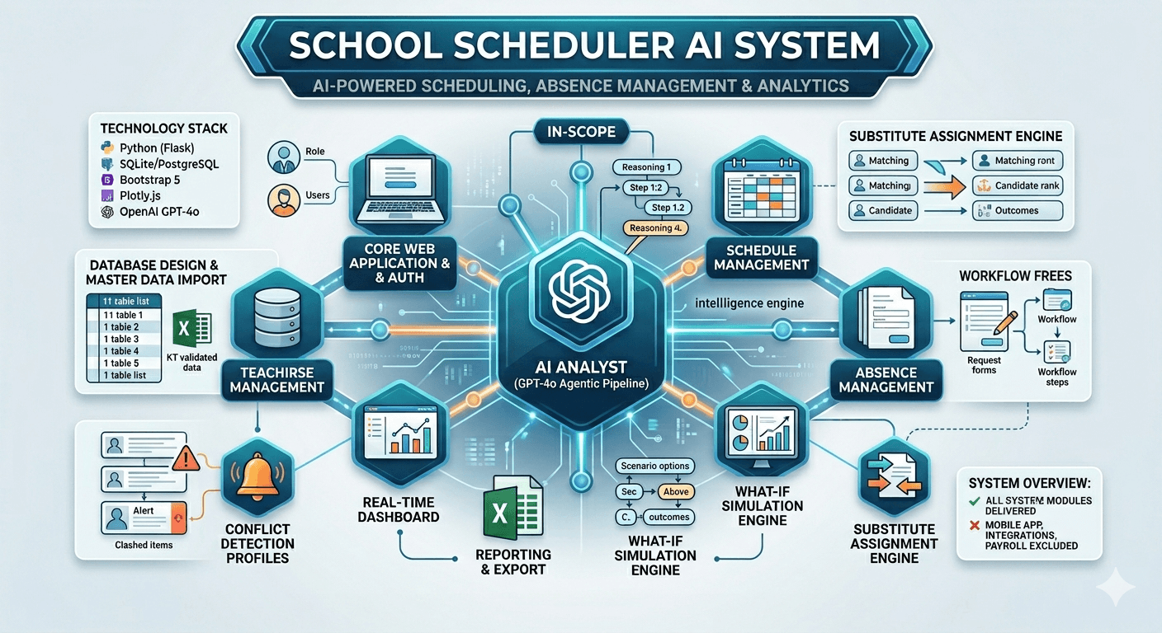

The Results
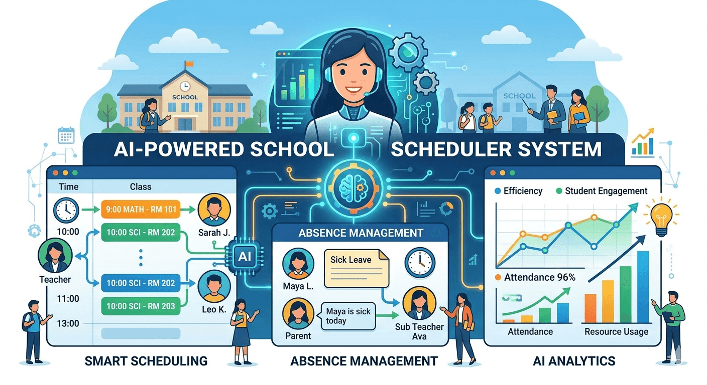
🗓️ Scheduling Chaos Eliminated Manual timetable management replaced entirely with intelligent automation — real-time updates, zero coordination errors, and instant conflict resolution.
🤖 AI-Powered Decision Making Administrators ask operational questions in plain English and receive instant, accurate answers — no analysts, no waiting, no guesswork.
👩‍🏫 Smarter Substitute Management The right substitute is automatically assigned based on expertise, availability, and workload — ensuring teaching continuity without overloading staff.
🔮 Proactive Planning with Simulations Administrators test scenarios before implementation — eliminating disruptions and improving operational preparedness across the entire school.
📊 Real-Time Operational Visibility A single platform provides complete visibility across schedules, absences, staff, rooms, and analytics — replacing fragmented systems with one source of truth.
🔒 Secure & Scalable Architecture Built to scale with the institution — handling growing data, users, and complexity with enterprise-grade security and access controls.

Impact Summary
Manual scheduling eliminated. Substitute assignment automated. Real-time AI insights delivered. Zero disruption to live operations.

Here's the fully rewritten case study:

Tag
DEVOPS & PLATFORM · SAAS
Title
How We Engineered a Production-Ready CI/CD Pipeline That Delivers Secure, High-Quality Software — Automatically
Subtitle
From manual deployments to a fully automated, security-first delivery pipeline — built on GitHub Actions, Kubernetes, and AWS.

The Challenge
In modern software development, speed without quality is a liability. And quality without speed is a competitive disadvantage.
Most engineering teams face the same painful reality — manual deployments are slow, error-prone, and inconsistent. Security vulnerabilities slip through undetected. Testing is rushed or skipped under delivery pressure. And by the time a bug reaches production, the cost of fixing it has multiplied many times over.
Three critical problems demanded an intelligent solution:
- Manual deployment processes were slowing release cycles and creating inconsistent, unreliable delivery
- Security and code quality checks were disconnected from the delivery workflow — catching problems too late
- Teams lacked real-time visibility into the delivery pipeline — blind spots created risk and reduced confidence

Technology Stack
GitHub Actions · Docker · SonarQube · Trivy · Kubernetes · AWS EKS · Terraform · Slack

Solutions Architecture:
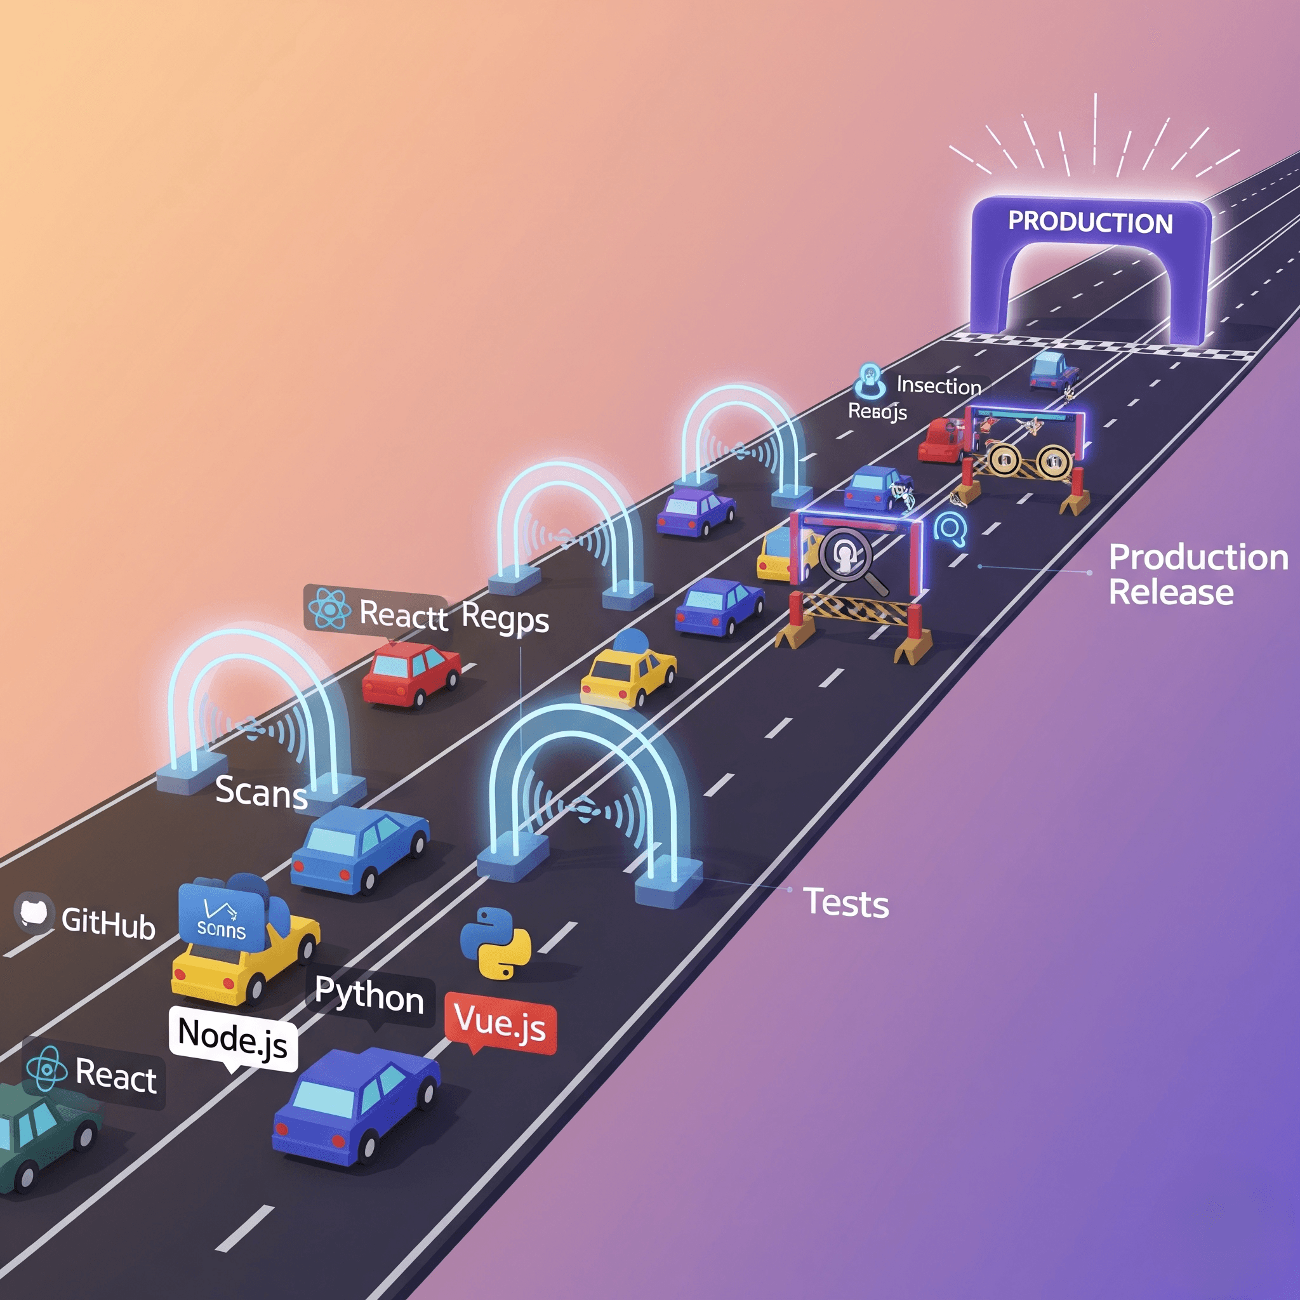

What Algorims Built
We designed and deployed RaaS — Release Automation as a Service — a fully automated, security-first CI/CD pipeline that takes code from commit to production with zero manual intervention, built on GitHub Actions, Docker, Kubernetes, and AWS.
The pipeline was engineered across four precision-designed stages:
Stage 1 — Code & Build The moment a developer commits code, the pipeline activates automatically. Source code is compiled, validated, and built into an optimised container image — ready for the next stage within minutes, not hours.
Stage 2 — Scan & Package Before a single line of code moves forward, it passes through automated security and quality gates. SonarQube performs deep static code analysis. Trivy scans for vulnerabilities across the container image and dependencies. Only clean, secure, quality-verified code advances — eliminating the risk of security debt reaching production.
Stage 3 — Deploy & Test The verified application is deployed to a dedicated staging environment on AWS EKS — provisioned automatically via Terraform. A comprehensive automated test suite then validates every dimension of the application: unit tests, end-to-end tests, and UI tests — all running in parallel, delivering fast, reliable feedback before a single line reaches production.
Stage 4 — Notify & Release Throughout every stage, stakeholders receive real-time Slack notifications — complete visibility into pipeline status, test results, and deployment progress. Once all gates are cleared, the verified release ships to production seamlessly, automatically, and with full confidence.

The Results
🚀 Deployment Speed Dramatically Increased Manual release cycles replaced by fully automated delivery — code moves from commit to production in a fraction of the time, with zero manual intervention required.
🔒 Security Built Into Every Release Automated SonarQube and Trivy scans ensure only clean, vulnerability-free code reaches production — security is a property of the pipeline, not an afterthought.
✅ Quality Assured at Every Stage Unit, end-to-end, and UI tests run automatically on every release candidate — catching bugs before they reach users and dramatically reducing production incidents.
☁️ Infrastructure as Code Terraform-provisioned AWS EKS environments are consistent, repeatable, and cost-effective — eliminating environment drift and making infrastructure management effortless.
👁️ Complete Pipeline Visibility Real-time Slack notifications keep every stakeholder informed at every stage — no more blind spots, no more deployment surprises.
📈 Engineering Teams Unblocked Developers focus on building features, not managing deployments. The pipeline handles the complexity — giving engineering teams back the time and confidence to move faster.

Impact Summary
Manual deployments eliminated. Security automated. Quality guaranteed. Teams shipping faster with complete confidence.

Tag
AGENTIC AI · ENTERPRISE KNOWLEDGE MANAGEMENT
Title
How We're Building an Enterprise Knowledge Mining Assistant That Answers Questions — Not Just Returns Files
Subtitle
Deploying a permissions-aware, retrieval-augmented AI assistant on Amazon S3 Vectors and Amazon Nova — giving enterprise employees instant, cited answers from thousands of documents.

The Challenge
Enterprises accumulate thousands of documents across SharePoint, S3, internal portals, and email systems. The knowledge is there — but finding it is a different problem entirely.
Employees waste hours hunting for policy answers, contract clauses, and SOP steps. Existing keyword search returns lists of files, not answers. The result is predictable:
- Slow onboarding — new employees spend weeks finding information that should take minutes
- Compliance risk — outdated or incorrect documents get actioned because the right one was never found
- Repeated SME escalations — subject matter experts fielding the same questions daily instead of focusing on high-value work
- Decision delays — leaders waiting for information that already exists somewhere in the organisation
The problem is not a lack of knowledge. It is a lack of intelligent access to it.

What Algorims Is Building
We are deploying a Permissions-Aware Enterprise Knowledge Mining Assistant — a production-grade retrieval-augmented AI system built on Amazon S3 Vectors and Amazon Nova that transforms how enterprises interact with their institutional knowledge.
Employees ask questions in plain English. The system retrieves the most relevant information from across the entire document estate, reasons through it using Amazon Nova, and delivers grounded, cited answers — instantly, securely, and without hallucination.
The system is engineered across six core capabilities:
Permissions-Aware Retrieval Built on Amazon S3 Vectors — users only ever see documents within their authorised access scope. Enterprise security and compliance requirements are enforced at the retrieval layer, not bolted on afterwards.
Citation-Grounded Answers Every answer links directly back to its source document and specific chunk — eliminating hallucinated facts and giving employees the confidence to act on AI-generated answers.
Multi-Format Document Ingestion PDF, DOCX, PPTX, HTML, and email formats all ingested, indexed, and made searchable — across SharePoint, S3, Confluence, Salesforce, and internal portals.
Incremental Document Sync The system tracks document changes and updates incrementally — no full re-indexing required when documents are added or modified, ensuring the knowledge base stays current without operational overhead.
Intelligent Fallback Handling When confidence scores fall below threshold — the system escalates rather than guessing. Enterprise AI that knows the boundaries of its own knowledge is safer than one that doesn't.
Continuous Improvement Loop User feedback ratings feed directly into relevance tuning — the system gets measurably smarter with every interaction, compounding value over time.

The Technology
The assistant is built on a carefully selected AWS AI stack — purpose-designed for enterprise knowledge mining at scale:
Amazon S3 Vectors — The semantic index layer. Stores and retrieves high-dimensional vector embeddings across the entire document estate with enterprise-grade security and permissions mirroring built in.
Amazon Nova / Nova Lite — The generative reasoning layer. Processes retrieved context and generates grounded, accurate, citation-backed answers in natural language — with full support for Singapore region (ap-southeast-1).
Amazon Bedrock Guardrails — PII redaction and content safety controls applied automatically — without custom code or additional infrastructure.
Enterprise Connectors — Native integrations with SharePoint, S3, Confluence, and Salesforce — connecting every document source your organisation relies on.

What This Delivers for the Enterprise
⚡ Instant Knowledge Access Employees get precise, cited answers in seconds — not lists of files to manually search through. Hours of hunting reduced to a single natural language query.
🔒 Zero Security Compromise Permissions-aware retrieval ensures every user only accesses documents within their authorised scope — enterprise ACL requirements enforced natively.
✅ Answers You Can Trust Every response cites its source — eliminating hallucinated facts and giving employees the confidence to act on AI-generated answers immediately.
📉 SME Escalations Dramatically Reduced Repeated questions answered autonomously — freeing subject matter experts to focus on high-value work instead of fielding the same queries daily.
🚀 Fast Time to Value Fully functional in under a week from architecture to first demo — production deployment designed for speed without compromising enterprise security standards.
🌏 Singapore-Ready Deployed in ap-southeast-1 — meeting data residency requirements for Singapore and Southeast Asia enterprise clients.

Technology Stack
Amazon S3 Vectors · Amazon Nova · Amazon Nova Lite · Amazon Bedrock Guardrails · AWS IAM · SharePoint Connector · S3 · Confluence · Salesforce

Impact Summary
Hours of document hunting eliminated. SME escalations reduced. Cited, trustworthy answers delivered instantly — at enterprise scale.

Tag
AGENTIC AI · FINANCE· SINGAPORE SMB
Title
How We Are Building an AI-Native Finance Document Processing Platform That Eliminates Manual Work — From Invoice to ERP in Minutes
Subtitle
A fully automated, compliance-ready finance automation platform built on AWS Bedrock and Claude — designed specifically for Singapore SMBs.

The Challenge
Singapore SMBs process hundreds of finance documents every month — invoices, purchase orders, GST returns, financial statements, and tax documents. Almost all of it manually.
The hidden cost is enormous:
- Finance teams spend hours manually extracting data from documents — keying figures that should never require human input
- Validation errors slip through unchecked — incorrect UEN numbers, invalid GST registrations, and reconciliation mismatches creating compliance risk
- Approval workflows live in email chains — no visibility, no audit trail, no accountability
- ERP data entry is done by hand — slow, error-prone, and impossible to scale
- Exception handling consumes disproportionate time — finance teams firefighting instead of adding value
For Singapore SMBs navigating ACRA compliance and GST requirements, the stakes are high and the margin for error is zero.

What Algorims is Building
We designed and built an AI-Native Finance Automation Platform — a production-ready, end-to-end document processing system built on AWS Bedrock and Claude that takes finance documents from ingestion to ERP export autonomously, with full compliance validation, role-based approvals, and a complete audit trail.
The platform was engineered across six integrated capabilities:
Intelligent Document Processing (IDP) Claude on AWS Bedrock extracts structured data from every finance document type — invoices, purchase orders, GST returns, financial statements, and tax documents — with human-level accuracy and zero manual keying required.
Singapore Compliance Validation Built-in ACRA UEN and GST validation rules automatically verify every document against Singapore regulatory requirements — catching compliance errors before they become costly problems.
Retrieval-Augmented Generation (RAG) Claude-powered RAG layer enables finance teams to query their entire document history in plain English — instantly surfacing contract terms, payment histories, vendor records, and policy details without manual searching.
Automated Approval Workflows Real-time exception and approval queues route documents intelligently based on value thresholds, document type, and business rules — giving finance managers complete visibility and control without email chains.
Automated Reconciliation AI-driven reconciliation matches invoices against purchase orders, delivery notes, and payment records automatically — identifying discrepancies instantly and flagging exceptions for human review.
ERP Export Validated, reconciled financial data exported directly to ERP systems — eliminating manual data entry entirely and ensuring your financial records are always accurate, current, and audit-ready.
Role-Based Access & Full Audit Trail Every action, approval, and exception is logged with a complete, tamper-proof audit trail — giving finance teams, auditors, and compliance officers the visibility they need, with role-based access ensuring the right people see the right documents.

The Results
⚡ Finance Document Processing Automated End-to-End From document ingestion to ERP export — the entire finance workflow runs autonomously. Manual data entry eliminated. Processing time reduced from hours to minutes.
🇸🇬 Singapore Compliance Built In ACRA UEN and GST validation rules enforced automatically on every document — eliminating compliance risk and ensuring regulatory requirements are met without manual checking.
🤖 Claude-Powered Extraction Accuracy AWS Bedrock Claude delivers human-level document extraction accuracy across all finance document types — invoices, POs, GST returns, financial statements, and tax documents.
📊 Complete Approval Visibility Real-time exception and approval queues replace chaotic email chains — every approval tracked, every decision logged, every stakeholder informed.
🔍 Instant Document Intelligence Finance teams query their entire document history in plain English — contract terms, payment histories, vendor records surfaced instantly through Claude-powered RAG.
🔒 Enterprise-Grade Security Role-based access controls and a full audit trail ensure complete accountability — audit-ready from day one, with zero additional compliance overhead.
📈 Scales With Your Business Built on AWS serverless architecture — the platform handles growing document volumes, users, and complexity without additional infrastructure investment.

Technology Stack
AWS Bedrock · Claude (Anthropic) · Amazon S3 · Amazon Textract · AWS Lambda · Amazon DynamoDB · AWS IAM · ACRA UEN Validation · GST Compliance Rules

Impact Summary
Manual finance processing eliminated. Singapore compliance automated. Invoice to ERP in minutes — not hours.

Status
🟡 POC Complete — Ready for Client Deployment The platform is fully built, tested, and production-ready. We are actively seeking Singapore SMB partners to deploy and scale this solution.

